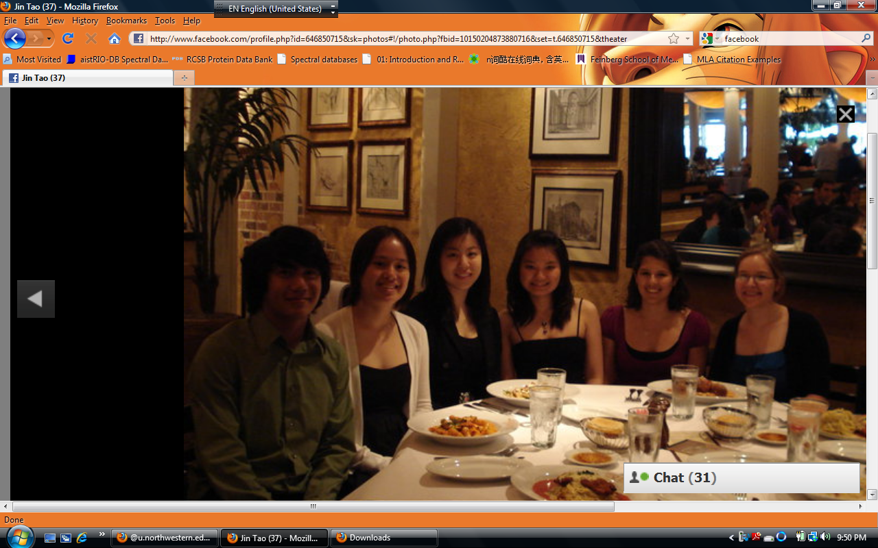

Name: Jin Tao

Position title: Vice President

Major: Biomedical Engineering

Interests:

Philanthropy, Calligraphy, Painting, Playing Guzheng (sting instrument), Watching Movies with friends, and traveling.